Scalable Static Website with S3 + Cloudflare + GitHub Actions Objective:

Host and auto-deploy a static website using S3 (free tier) with global CDN and HTTPS via Cloudflare, triggered through GitHub commits. Tools: AWS S3 (Free), Cloudflare (Free), GitHub Actions, HTML/CSS, Bash Mini Guide: Create a static HTML site and push to GitHub. Set up GitHub Actions to sync content to an S3 bucket. Connect S3 to a custom domain via Cloudflare and enable SSL. Add cache settings and versioning. Deliverables: GitHub Actions CI/CD workflow Cloudflare + S3 integration steps Live website link with HTTPS Screenshot + deployment report.

**Step-by-Step Instructions:**

**1. Create a Static Website**

* Make a folder like my-site
* Add files:

my-site/

├── index.html

└── style.css

index.html:

<!DOCTYPE html>

<html>

<head>

<title>My Site</title>

<link rel="stylesheet" href="style.css">

</head>

<body>

<h1>Hello from AWS S3!</h1>

</body>

</html>

Style.css:

body {

    background-color: #f4f4f4;

    font-family: 'Segoe UI', Tahoma, Geneva, Verdana, sans-serif;

    margin: 0;

    padding: 0;

    text-align: center;

}

h1 {

    color: #333;

    margin-top: 20%;

    font-size: 3em;

    text-shadow: 1px 1px 3px rgba(0, 0, 0, 0.1);

}

**2. Push to GitHub**

* Create a repo on GitHub.
* Initialize local git and push:

Bash:

git init

git add .

git commit -m "Initial commit"

git remote add origin https://github.com/your-username/repo-name.git

git push -u origin main

**3. Create AWS S3 Bucket**

* Go to [AWS S3](https://s3.console.aws.amazon.com/s3/)
* Click “Create Bucket”:
  + Name: ashrithbucket1
  + Uncheck “Block all public access”
* Upload index.html and style.css
* Enable static website hosting under “Properties”

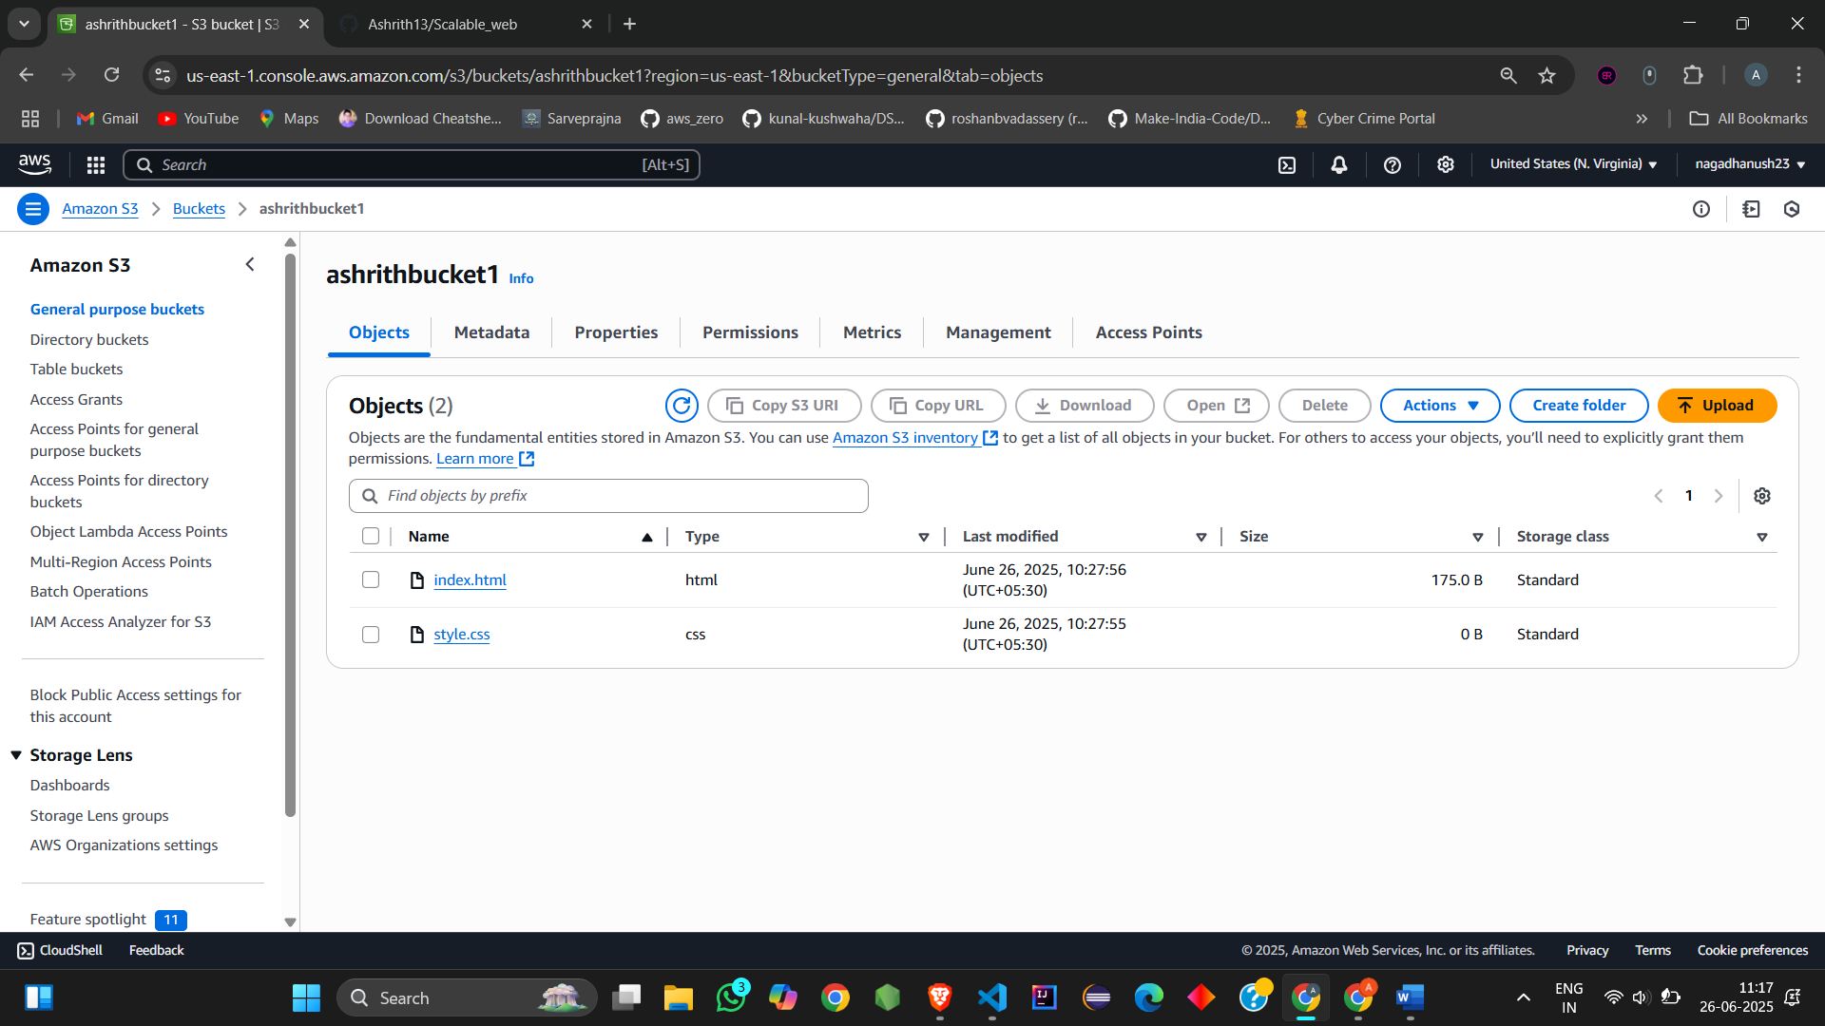

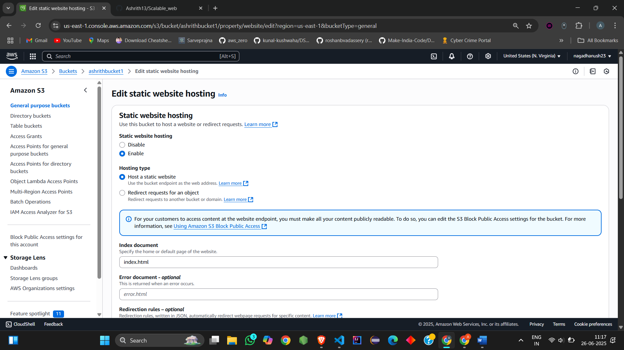

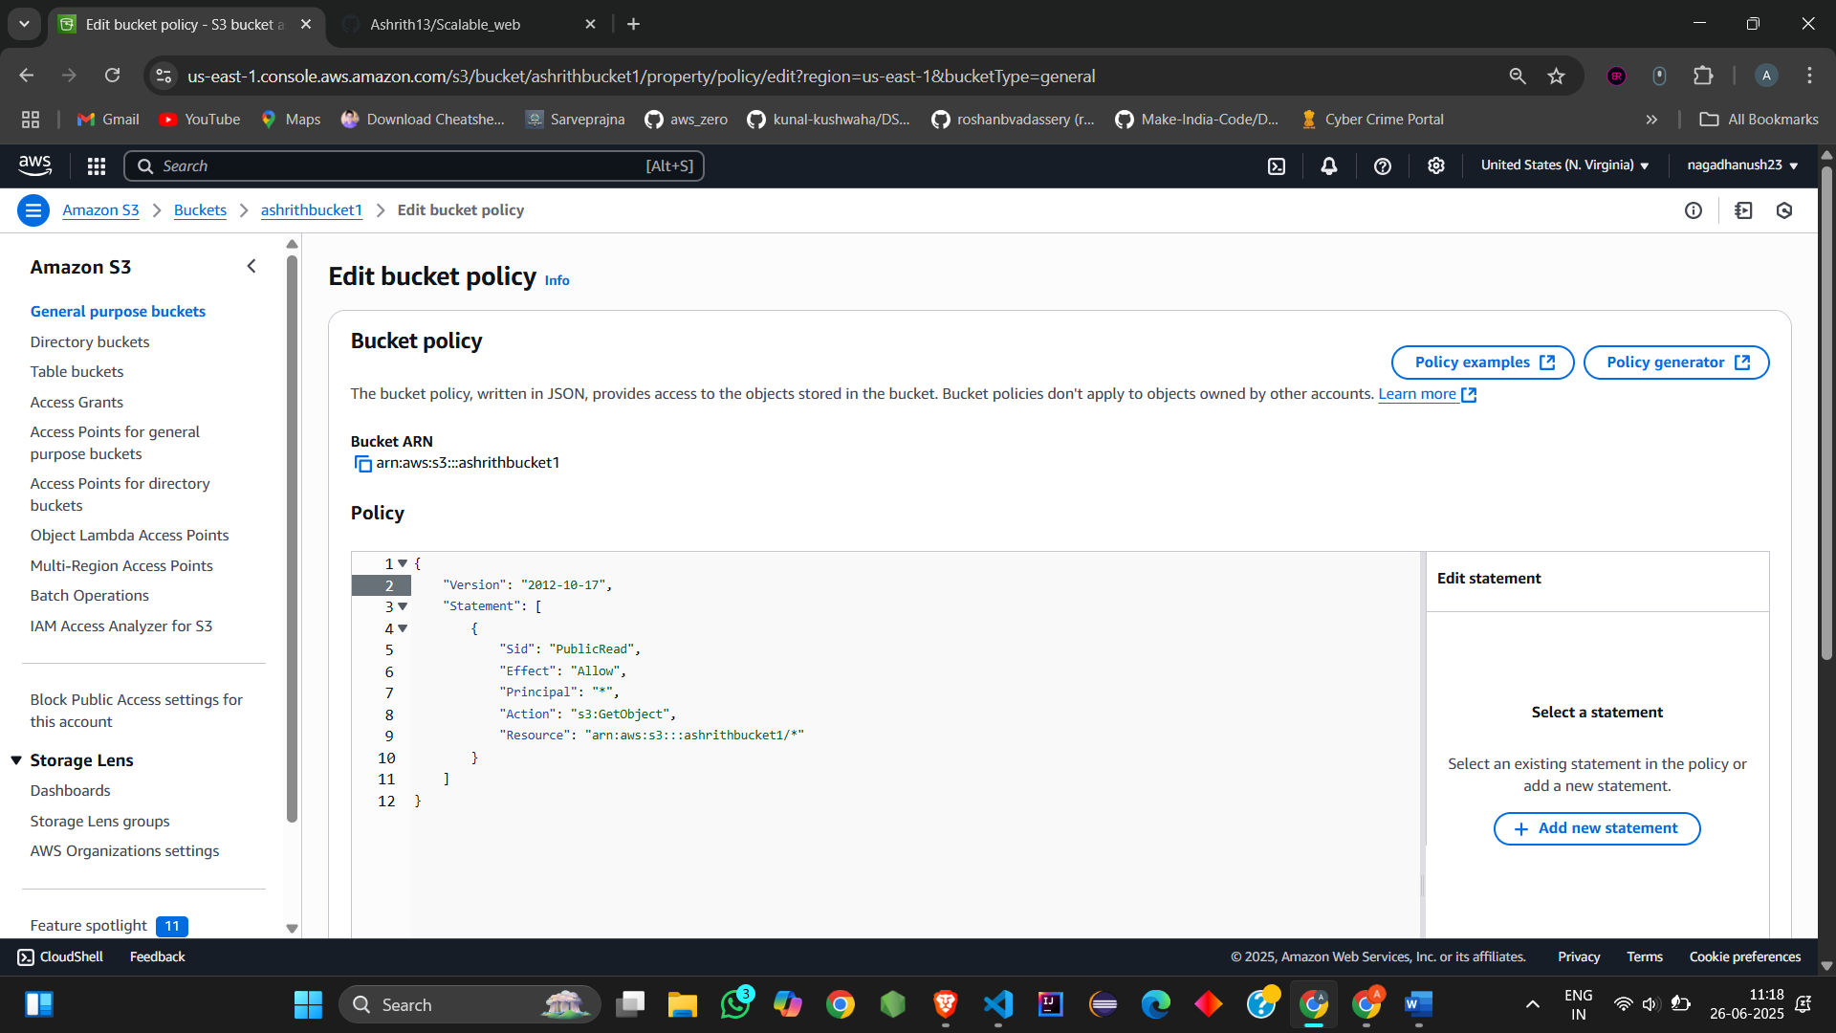

**4. Configure GitHub Actions**

* Add this under .github/workflows/deploy.yml:

Yaml:

name: Deploy to S3

on:

push:

branches: [ main ]

jobs:

deploy:

runs-on: ubuntu-latest

steps:

- uses: actions/checkout@v2

- name: Sync files to S3

uses: jakejarvis/s3-sync-action@master

with:

args: --delete

env:

AWS_S3_BUCKET: ashrithbucket1

AWS_ACCESS_KEY_ID: ${{ secrets.AWS_ACCESS_KEY_ID }}

AWS_SECRET_ACCESS_KEY: ${{ secrets.AWS_SECRET_ACCESS_KEY }}

AWS_REGION: ap-south-1

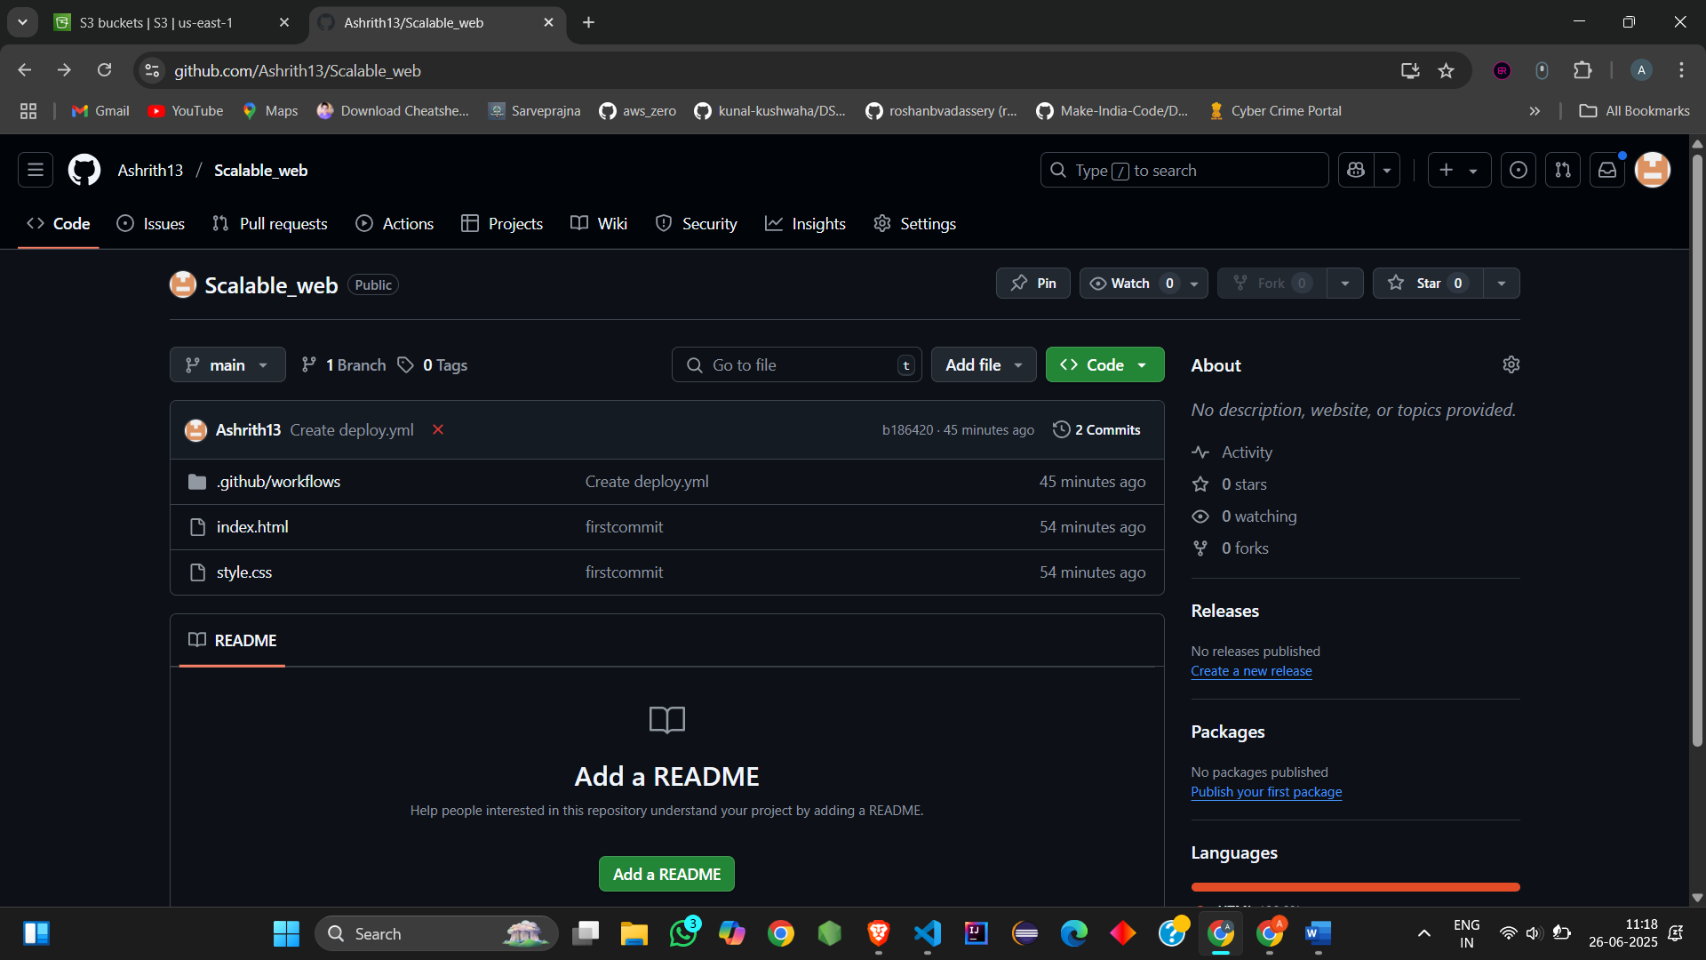

**5. Connect to Cloudflare**

* Go to Cloudflare
* Add your domain (or buy a free one like from Freenom)
* Update nameservers on your domain registrar
* Set S3 bucket URL in DNS records (CNAME or A record)

**6. Enable SSL and Cache**

* Turn on SSL in Cloudflare (Full or Flexible)
* Enable “Always use HTTPS”
* Enable “Caching Level: Standard” for faster loading

**🡪Option 1: Use a Custom Domain**

If you want to use Cloudflare + AWS + SSL, you need to **get your own domain name** like:

* ashrithweb.ml (from Freenom — if it works again)
* or buy a cheap one from Namecheap / GoDaddy (~₹100/year)

**Then:**

* Connect your custom domain to Cloudflare
* Set A/CNAME records to your AWS S3 endpoint
* Use full DNS + HTTPS (we can guide you)

**🡪Option 2: Skip Cloudflare and Use InfinityFree Hosting Directly**

If you're happy to **just host your files**, you can upload them to **InfinityFree File Manager**, skipping S3 and Cloudflare completely.

Here's how:

**Step-by-step to host on InfinityFree:**

1. Go to your **InfinityFree control panel**
2. Open **File Manager**
3. Go to folder: htdocs
4. Upload your files (index.html, style.css, etc.)
5. Open your site at:

Arduino:

https://ashrithbucket1.42web.io

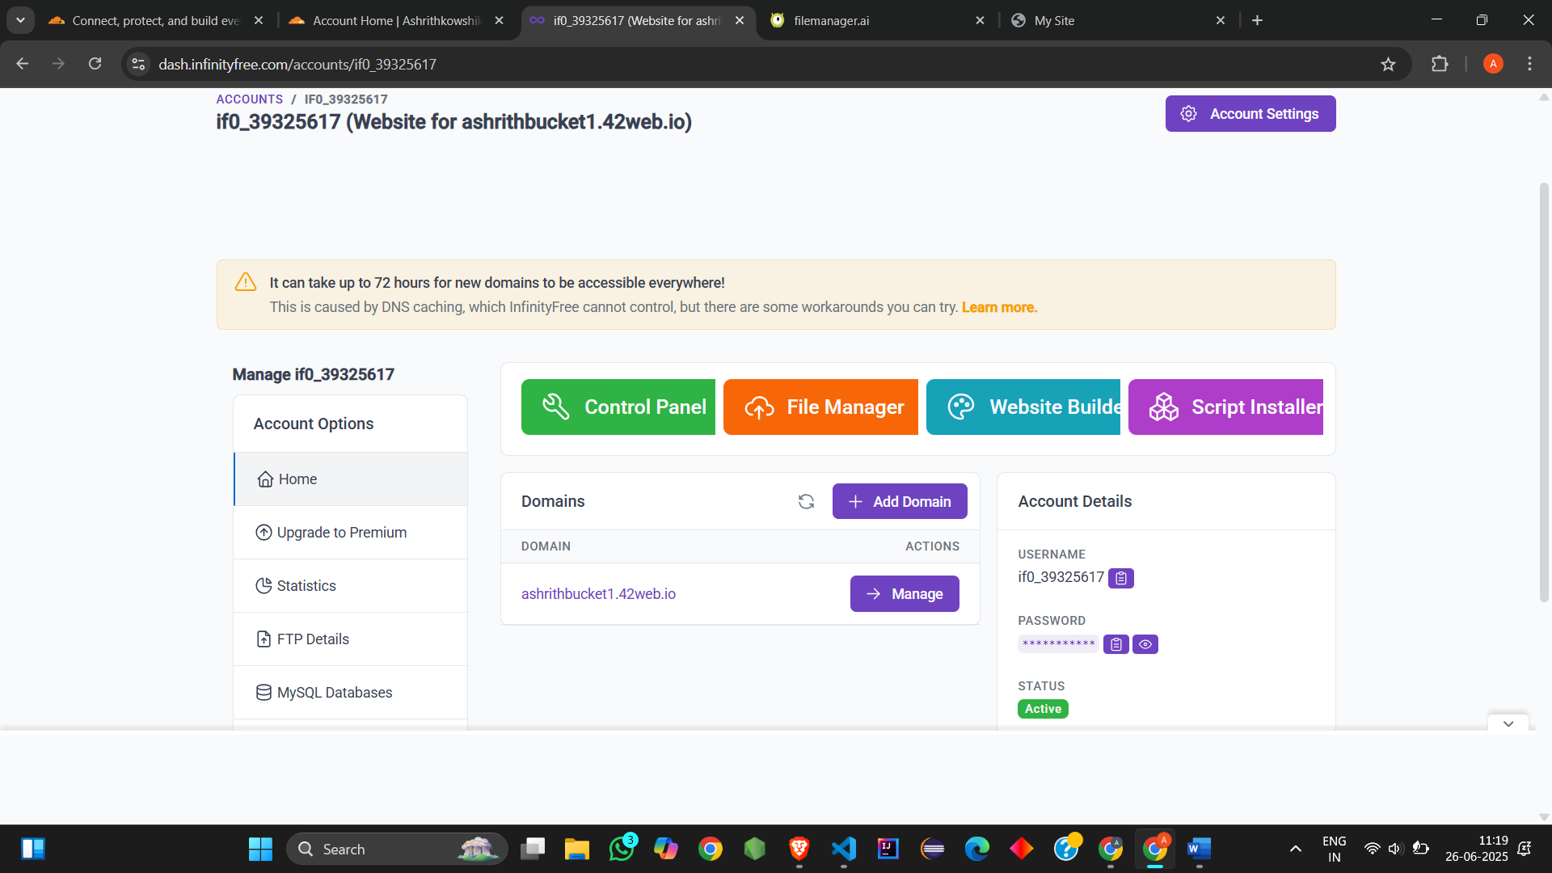

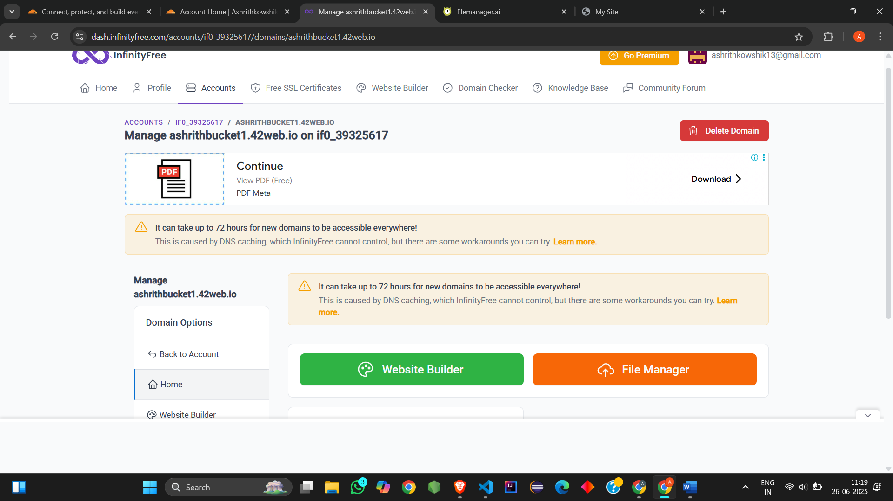

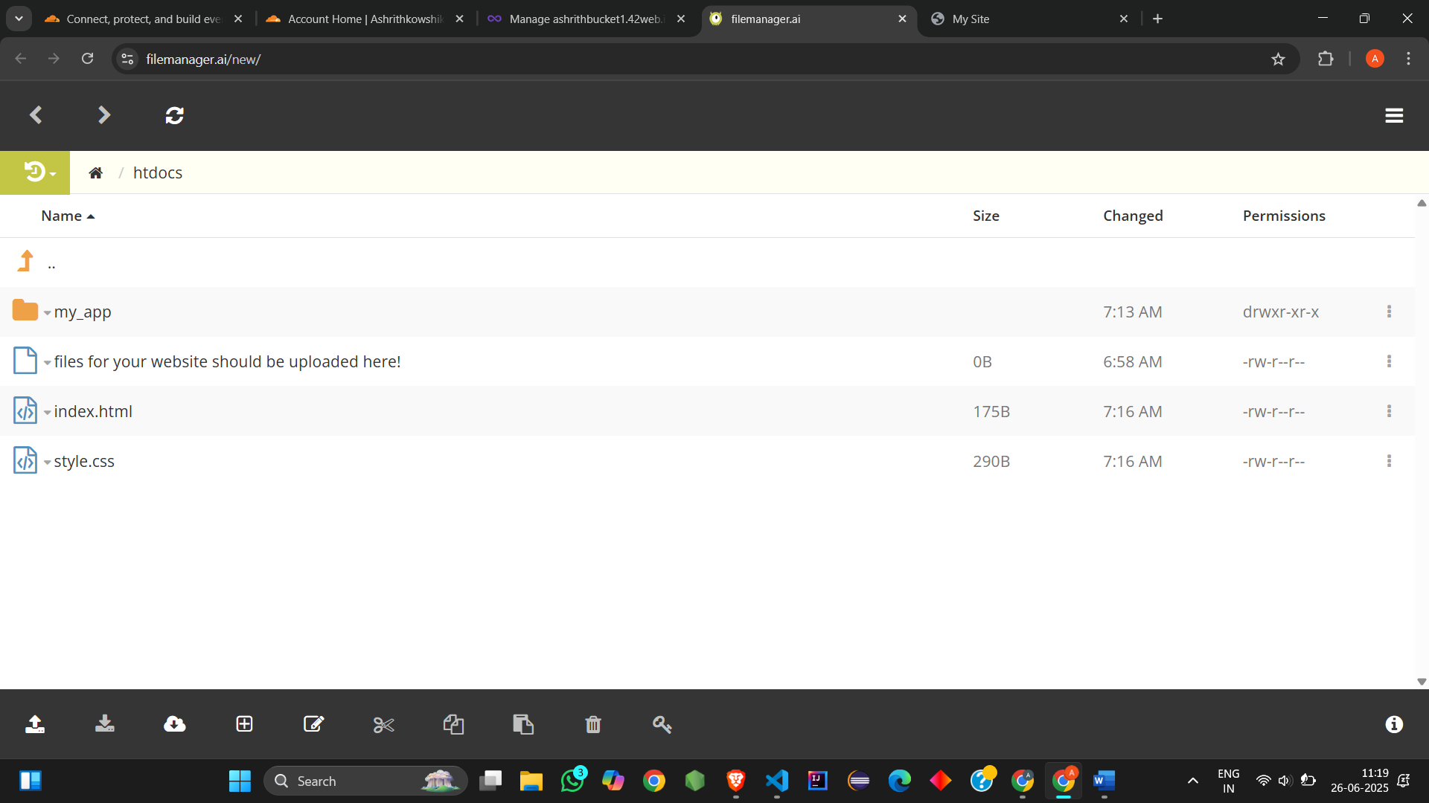

Output: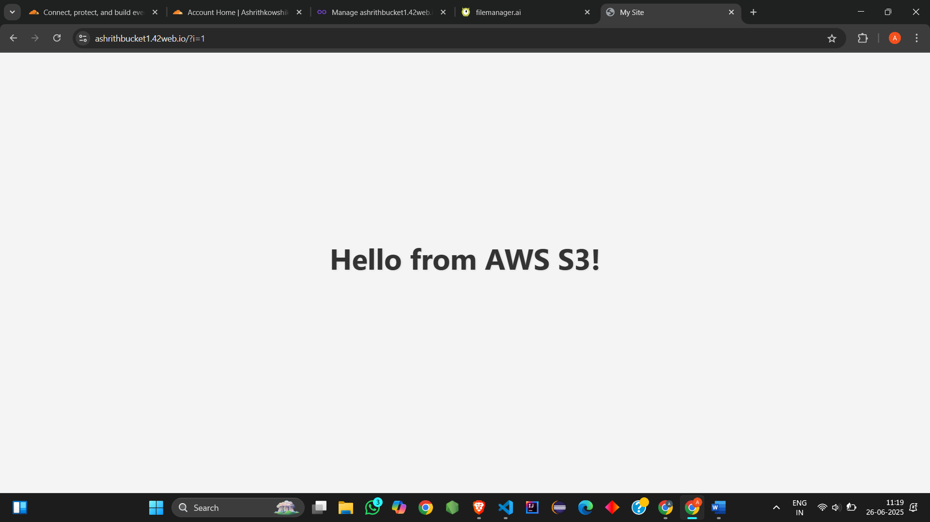

Github Link:

https://github.com/Ashrith13/Scalable_web/tree/main